

**Subject Human-Comeputer Interaction**

**Project name PetAssistant Based on Speech Recognition**

**Report maker 2151938 杨昕迪**

**2152957 罗国蔚**

**2154172 曹洪瑞**

**Date 6,7,2023**

1. **Brief description of the program**

Structure of the program:

The program is mainly composed of five classes

**PetAssistant class:** it contains the initialization of main parameters, creation of main form, electronic pet assistant state adjustment, left-right shift function, mouse state reading, music playing and other functions of the interface.

**Eat class:** contains subform creation and restaurant recommendation generation functions

**Weather class:** including subform creation and querying the weather information of Shanghai through api secret key provided by openweathermap website.

**Translation class:** contains the creation of sub-forms and the translation of the input Chinese using the Youdao translation api

**SpeechRecognitionThread class:** the speech recognition thread class, the speech recognition will run independently as a separate thread, using the Google interface to accurately identify Chinese speech, provided to the PetAssistant class as parameters

1. **The implemented requirements**

Some screenshots of a sample run is shown below

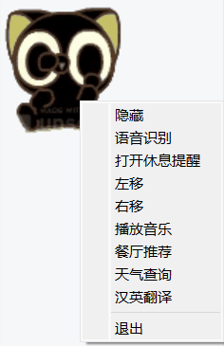

1. Standby status (all gifs):



1. Reminder function:

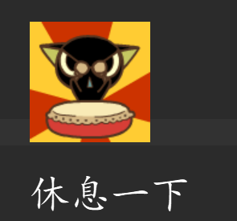

3.Move right or left

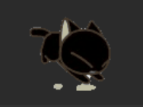

4.Play Music：

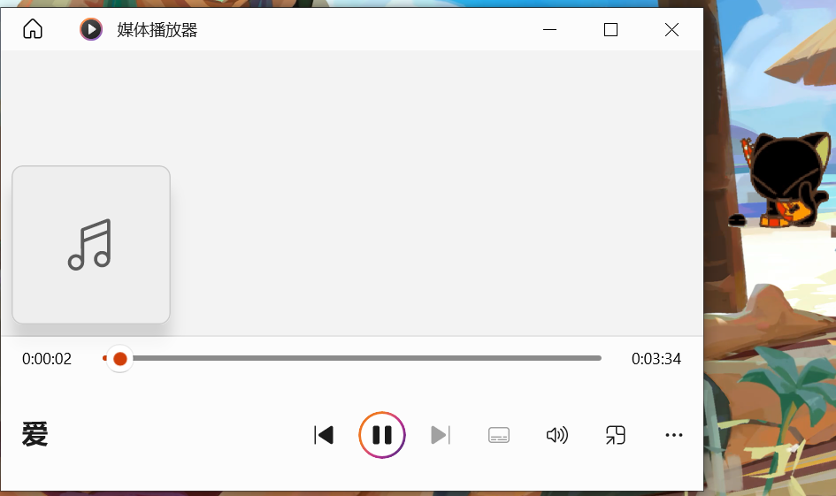

5.Weather Search：

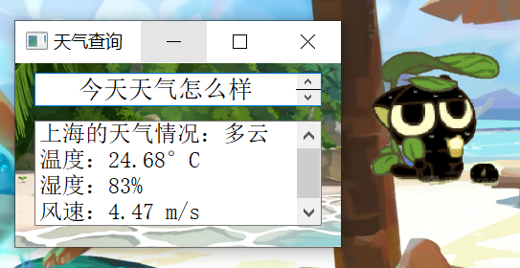

6.translate：

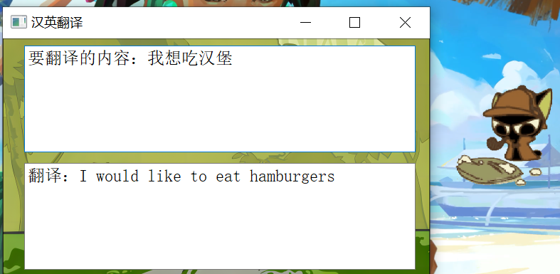

7.Dinner recommend：

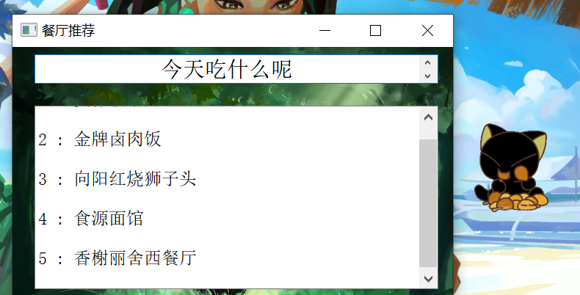

The program runs and displays Pet Assistant on the desktop and an icon in the tray. Pet Helper has three resident actions, and special actions appear when clicked. It supports moving with mouse dragging after clicking.

Right-clicking Pet Assistant will bring up a menu of functions, including Hide, Voice Recognition, Turn on (off) Rest Reminder, Move Left, Move Right, Play Music, Restaurant Recommendation, Weather Search, Chinese-English Translation, and Exit.

Clicking "Hide" will hide the pet assistant, which can be restored in the tray; clicking "Voice recognition" will start the voice recognition thread, and the slot function of the thread will send back voice commands, so the pet assistant can process the user's voice commands and support all commands in the user's command manual. All commands;

Click on "Open break reminder", the pet assistant will remind the user to take a break every once in a while and play a special animation, the user can cancel the special animation after clicking; click on "Move left" or "Move right "Move left" or "Move right" will move the pet one third of the screen width to the left or right respectively and play a special animation;

Clicking on "Play Music" will play the song "Because of Love" (other songs can be specified by voice command here) and play special animations;

Clicking on "restaurant recommendation", Pet Assistant will recommend five restaurants in Jiading district and play a special animation;

Clicking on "weather query", Pet Assistant will query and display the current weather in Shanghai and play a special animation;

Clicking "Chinese-English translation" will translate the Chinese phrase "Lao Mo, I want to eat fish" into English (here the voice command can be specified to translate other content) and play a special animation;

Clicking "Exit" will exit the application.

**3. Advantages and disadvantages of the program**

Advantages:

1. **Good encapsulation:** The code adopts the idea of object-oriented programming and encapsulates related functions in different classes, which improves the modularity and maintainability of the code.

2. **Good scalability:** By defining the functions and methods of each functional module, the code has good scalability and can easily add new functions or modify existing functions.

3. **Beautiful graphical interface**: By using PyQt library, a beautiful graphical interface is realized, which provides a good visual experience to users.

Flexible event handling: By rewriting functions such as mouse events and context menu events, flexible responses to user operations are achieved, providing an interactive user experience.

4. **Multi-threaded processing**: By running the speech recognition function in a separate thread, the blocking of the main interface is avoided and the responsiveness of the application is improved.

5. **Comprehensive functions:** The code covers multiple functions of the pet assistant, including pet animation display, mouse interaction, voice recognition, restaurant recommendation, weather query, Chinese-English translation, etc., which meets the diversified needs of users.

6. **Perfect resource management:** It provides good support for external resources through reasonable resource management, such as initializing image resources, reading dialogue text files, etc.

7. **Uniform code style:** The overall style of the code is consistent, using standardized naming and indentation, which increases the readability and maintainability of the code.

8. **Cross-platform compatibility:** Due to the use of PyQt library for development, the code can run on different operating systems and has good cross-platform compatibility.

9. These advantages make the code well **scalable and maintainable**.

Although the code has many advantages, there are some disadvantages, including

Disadvantages:

1. Imperfect error handling: The code lacks adequate handling of exceptions and error hints, which may cause the program to crash under error conditions or produce unexpected behavior.

2. Lack of input validation: The lack of adequate validation and handling of user input or external data may trigger security vulnerabilities or erroneous results.

3. Poor code extensibility: When new features need to be added or modifications made, the code structure and design may not be flexible enough, leading to difficulties in expansion and increased maintenance costs.

**4. Program improvement**

This PetAssistant project still has some functional shortcomings, we think the following improvements can be made in the future:

1. further compress all the functions into the speech recognition panel, i.e. the program will do it automatically according to the voice request, without having to click into the relevant interface
2. We believe that a new chat function can be added in combination with the large language model GPT (not realized due to cost constraints)
3. In order to solve the problem that recognition is not smart enough and must strictly follow the usage requirements, we think we can verify the semantic consistency by talking to GPT from the GPT interface after combining GPT, so that more complex commands can be recognized.

**5.Function introduction**

**PetAssistant class:**

**init():** initialize the form without title and displayed at the top.

**initPall():** initialize the tray. Set the tray icon and menu items.

**initPetImage():** initialize the animation when the pet assistant appears, the resident part animation and the text box needed for the timed reminder function later, set the vertical layout.

**petNormalAction():** set two timers, one of them is set to 5 seconds, the slot function is connected to randomAct function (used to change the displayed animation, which will be introduced later), i.e. the animation of the resident part is automatically switched every 5 seconds. The other timer is used for timing the reminder function at regular intervals.

**randomAct():** set different animations and display them according to different status symbols (self.condition and self.dir, including resident, click, timed reminder function, left shift, right shift, play music function, restaurant recommendation function, weather query function and Chinese-English translation function, which correspond to different animations respectively).

**quit():** used to exit the program at the tray icon.

**shouwin():** used to display the pet helper at the tray icon, by adjusting the transparency of the form.

**randomPosition():** get the window coordinates, set the pet helper to appear randomly when the program starts to run by random number.

**mousePressEvent():** Bind the pet helper to the mouse position when the left mouse button is pressed. Change the status of the pet helper to "click" and change the mouse style.

**mouseMoveEvent():** When the left button is pressed and the position is bound, the pet helper moves with the mouse.

**mouseReleaseEvent():** Release the mouse state and restore the original state.

**enterEvent():** set the style when mouse move.

**contextMenuEvent():** open menu when right click on the pet, the menu contains hide, voice recognition, open (close) rest reminder, move left, move right, play music, restaurant recommendation, weather query, Chinese-English translation and exit. Clicking on each menu item will execute the corresponding module code.

handle_speech_recognition_completed(speech_text): handle the recognized voice commands.

**haveRest():** the word "take a break" appears, change the pet assistant's status charm to timed reminder function and play the corresponding animation.

**moveLeft():** Calculate the new coordinates after shifting to the left by one-third of the screen width by the current form coordinates, and call the move function with each unit length as a loop to achieve the visual effect of moving. Change the pet helper's status symbol to resident and play the corresponding animation.

**moveRight():** Calculate the new coordinates of the current form after shifting to the right by one-third of the screen width, and call the move function with each unit length as a loop to achieve the visual effect of moving. Change the pet helper's status symbol to resident and play the corresponding animation.

**changemoving():** change the status of pet helper to move (change self.condition to move, then determine the direction of move according to self.dir) and play the corresponding animation.

**playMusic(filename):** open the corresponding pre-saved audio file. Change the status of pet helper to play music and play the corresponding animation.

**canteenRecommendation():** Create Eat subform and display it. Change the pet helper's status symbol to the restaurant recommendation function and play the corresponding animation.

**weatherReport():** Creates and displays the Weather subform. Change the pet helper's status symbol to weather report and play the corresponding animation.

**trans_Ch_to_En(text):** Creates and displays the Translation subform. Change the pet helper's status symbol to Chinese-English translation and play the corresponding animation.

**movieStarted():** the slot function to play the animation of the moving part, delay 0.1 seconds after playing the moving animation and then move the window. Under the underlying logic of Qt module, the priority of moving the window is higher than playing the animation, so it needs to be delayed, otherwise it will show the wrong animation.

**Eat class:**

**init():** set the size, background, title, etc. of the child form, read the pre-saved menu.

**add_ui():** set two text boxes, the first text box centered output "what to eat today"; the second text box randomly extract five items from the menu output.

**closeEvent():** exit the subform.

Weather class:

**init():** set the size, background, title, etc. of the subform.

**add_ui():** set two text boxes, the first text box is centered to output "What's the weather today"; use the purchased api key to query the weather information of Shanghai in the api provided by openweathermap website and output in the second text box.

**closeEvent():** exit the subform.

**Translation class:**

**init():** set the size, background, title, etc. of the subform and read the pre-saved menu.

**add_ui():** set two text boxes, the first text box outputs the Chinese to be translated; the translated English is queried through the api of Youdao Translation and output in the second text box.

**closeEvent():** exit the subform.

**SpeechRecognitionThread class:**

**init():** call the parent class to initialize

**run():** speech recognition module, using the interface provided by Google to accurately identify Chinese voice commands, pass the slot function to the relevant function of PetAssistant-type variables to execute the relevant commands.